James McLellan
Communication Plan
Bells for St. Jude’s

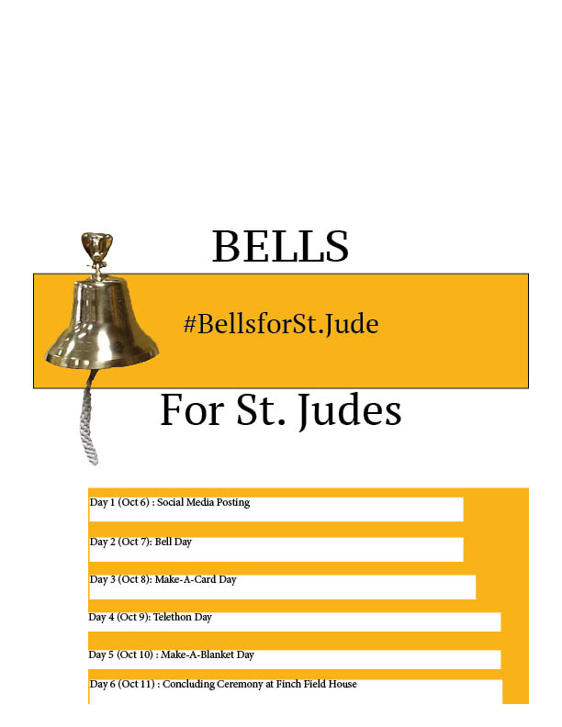

- TABLE OF CONTENTs

Contents
EXECUTIVE SUMMARY 3
RESEARCH 4
Client Research. 4
Opportunity or Problem 8
Audience. 10
OBJECTIVES 11
Impact 11
PROGRAMMING 12
Theme 13
Key messages 13
Audiences: 14
Channels 14
Social Media Influencers 14
Personnel 15
Budget 16
Timeline 16
EVALUATION of 17
CONCLUSION 19
APPENDICES 20
Social Media Posts: 20
Press Release 24
Flyer 26

EXECUTIVE SUMMARY
The purpose of this Communication Plan is to show how a local Michigan company can help give back to an organization that makes a difference in many family’s lives. The communications plan will highlight how Bells, a Michigan brewery which one would not associate with creating a strategic partnership with an organization that deals with helping with funding research of specifically cancer and diseases for kids. I will show how this is done through conducting research, acknowledging objectives, tactics and themes. Concluding the campaign, ultimately both parties in the partnership will benefit. Bells will have the benefit of re-creating their brand image, while St. Jude’s will ultimately gain more funding and awareness for their organization. Central Michigan University students will be aware of giving back to St. Jude’s and be more educated on the topic. This is a campaign that after running smoothly could ultimately end up happening across the state of Michigan at another Michigan university. We will be using a local non-profit crowdfunding platform called Patronicity. This will be of benefit because it will help with promotions of the event, along with reaching donors to the campaign outside of the state of Michigan.

RESEARCH

Client Research.

Bells is a Michigan based brewery located in both Kalamazoo and Comstock Michigan. The brewery is popular due to a few well-known beers that they brew such as Oberon, Two Hearted Ale, Best Brown Ale, Winter White Ale, Lager of the Lakes, and Amber Ale. Bells also has its own restaurant known as the Eccentric Café. The Eccentric Café offers over 20 different craft beer options, a full-service restaurant, and a beer garden on the premises.

Bells came into existence during the late 1970s when its founder Larry Bell started working at Sarkozy Bakery. It was during this time period that Bell initially became interested in yeast and fermentation. With his new found interest Bell began brewing and thus saw an opportunity. In 1983, Larry Bell opened his first store which was a homebrew supply store under the name Kalamazoo Brewing Company. September 19, 1985 marked a historic date for Bell as it was the date that he sold his first commercial brew. By 1990 Bells had expanded beyond the Michigan market, and was shipping more than 500 barrels annually and began working with wholesaler Rave Associates, of Ann Arbor. As Bells grew as a company, so had their demands. Looking at this as an opportunity the brewery became the first Michigan brewery to open an onsite pub, established as the Eccentric Café, which underwent a $3 million renovation in 2011. The renovation added a state-of-the-art music venue, expanded restrooms, additional seating, a transformed Beer Garden, and a new patio area. In 2014 the breweries vision began expanding with the formation of a sister company known as Upper Hand Brewing joining the Bells family. Upper Hand is in Michigan’s Upper Peninsula in Escanaba. The brewery offers their own line of beers and can be found throughout Michigan and northern Wisconsin.

As of 2016, Bells saw it necessary to go through new branding and imaging. Especially with the brand growing on a large-scale base throughout many states In the United States. Branding efforts included working on the company logo and packaging to make them reflect the brand in present time but also reflect the companies past and essentially what made it into the brand that it is today.

In terms of social media activity, Bells is active on the three most popular social media platforms including Facebook, Instagram, and Twitter. Bells is most active on Facebook, utilizing two separate Facebook pages. One page is more general for Bells brewery, this page has a new posting once a day and on occasion there will be two posts. Facebook posts tend to be a little bit longer than on the other social media platforms and use different features to tell a story such as videos or articles which mention Bells. Some article mentions that Bells has posted to their Facebook include an article written by Sports Illustrated, where the article talked about the top craft beers at each MLB ballpark and Bells Two Hearted Ale along with Oberon made the top of the list at the Detroit Tigers Comerica Park. Another interesting article posted on Facebook was written by CraftBeer.com where experts gave opinions on the best craft beers to pair with the season’s girl scout cookies. Finally, another article recently posted by MLive talking about how Bells Two Hearted Ale was the Michigan Best pick for Beer of the Year 2018. Overall this Facebook page is interactive for those who follow or like the general Facebook page. The other Facebook page by Bells is more specifically for their Eccentric Café. The page is more the eccentric feel when you visit the page and is used similarly to the general Bells Brewery Facebook page in terms of how many posts are made a day. However, the page deals more with promoting the restaurant and upcoming events that the Eccentric Café will be hosting. Overall, Facebook is the primary social media platform used by the brewery.
Regarding other social media platforms, Bells is active with using Instagram and Twitter. Instagram is probably the second most utilized platform in terms of social media usage. The Instagram page correlates with Bells Facebook, as much of the content put on their Instagram is pulled from their Facebook. Posts are not made every day, as the latest posts were made three days apart from one another. On other occasions Bells will post on their Instagram two or three times a day if needed. However, this is only done in the instance that they are at a conference. Crunching numbers, Bells does have a large amount of Instagram posts totaling up to 1,470 posts. The page has 192K followers, but only follows 157 Instagram users. Twitter is used for some promotional use with 20.7k tweets, despite the large number of tweets the platform is used primarily for interacting with other twitter users and followers. The Twitter page has 160.8k followers and follows 414 pages back. Overall, Bells is not lacking in terms of social media usage.
Besides the use of social media platforms and articles published pertaining to Bells, the brewery also works to promote itself to other media outlets. At the bottom of the Bells website, they have a press page that will take you to their media room. The brewery does not put out a whole lot of press releases, especially in 2019. In terms of this year, the latest press releases done by Bells were on January 24 where they announced a 2019 release calendar. On February 20, 2019 Bells sent out a press release announcing that Oberon season will kick-off March 25th of this year. The latest press release done pertained to Bells new partnership with the Chicago Cubs and 670 The Score as Bells is the official craft beer of cub’s radio. Larry Bell, President and Founder of Bells talked about how he is excited about the new partnership as it will allow the brand to grow across the Chicagoland area. Although it is good that Bells is doing its own press releases, they could improve the format and layout of the releases. This is since the releases all feel the same.

Opportunity or Problem
Going through treatment for cancer can be one of the hardest both emotionally and physically things that anyone has had to go through. It has become almost a tradition and symbol of relief in the past for someone who has finished chemotherapy or radiation to ring a bell at the end of treatment. Ringing the bell, is ceremony that many cancer treatment facilities around the country now have. According to an article published by WebMD, a patient that has finished a course of chemotherapy or radiation rings the bell in ceremony while reading a wall-mounted poem alongside the bell. The intended purpose of the ceremony is to give a sense of closure to a difficult experience. For all involved in the difficult process and long journey, from the patient, their loved ones, to even the medical staff, the ceremony hits emotionally.
Having spent some time looking at Bells, I became well-aware of the fact that the company does an extraordinary job in promoting their presence on many different forms of media platforms. However, the only thing that the brewery ever really promotes is what is going on in their world of craft beer. As a company with the growing presence that they have, I thought that it would be worth addressing that they do not have a social presence in their local community. With this realization in mind, I saw the opportunity to create a philanthropic campaign for Bells to get themselves involved in. Putting two-and-two together, I came up with the idea that Bells could spread awareness and raise money for an organization like St. Jude’s. Since ringing a bell is a symbol of defeating cancer.
St. Jude Children’s Research Hospital has increased the childhood cancer survivor rate from 20 percent to over 80 percent since their existence 50 years ago. According to the St. Jude website. The research hospital is currently looking to increase childhood cancer survivor rates to 90 percent in total. Many opportunities are available for organizations of all sizes to partner with St. Jude’s. One problem, however, is that both St. Jude’s and Bells have policies prohibiting them from partnering with brands that deal with alcohol or children. As a solution to the problem, recognizing that Bells is more than just a brewery with their Eccentric Café and merchandising line offers the opportunity for Bells to grow their brand beyond the brewery that they are known for.
One of the main issues with treating cancer in children than for adult is that children require different methods of treatment often requiring more research. Some of the most common forms of cancer that children are more likely to get include leukemia, brain and spinal cord tumors, and neuroblastoma. Cancer.gov described how one major difference in treating childhood cancer as compared to adults is that their treatment is often more intense, and their bodies don’t react to drugs the same way that an adult human-being might.
Overall, as the Bells brand grows so does the opportunity for them to be able to make a difference. Bells working on this campaign can help raise enough money and awareness to change research being conducted at St. Jude Children’s hospital.

Audience.
To conduct my formal research, I used two different methods. When I first came up with my campaign Idea, I initially started asking people what they knew about Bells, what they knew about the bell ringing ceremony at places of treatment. I myself first became aware of the ceremony due to seeing random videos posted on social media. After asking around with a few of my friends and colleagues I was shocked that really no one knew about the ceremony. With the Bells familiarity question, it was only people from Michigan that new about it and not that many people were overall that interested in the brand unless they were a craft beer connoisseur. Once I asked around a little bit, I concluded that I should throw out a survey to try to gage a better understanding. From my first question, about familiarity with Bells about 76 percent of takers were aware, 15 percent were unsure, and about 9 percent said they were completely unaware. Another question I included was people’s familiarity with St. Jude’s where 87 percent were aware, 5 percent were aware but don’t know exactly what it is, and the remaining 8 percent were unaware. Finally, when I asked survey takers if they would be interested in attending an event or donating anything to an organization like St. Jude about 67 percent said yes, 22 percent said no, and 11 percent said they would consider it.

OBJECTIVES
- Output (Process and distribution; Counting activities, actions)
- Create and go-live with Patronicity campaign page
- Draft press releases and media advisories to send out to local media outlets
- Set-up social media pages (Facebook, Instagram, and Twitter)
- Create social media campaign for social media influencers to work with
- Promote Bells for St. Jude’s campaign on social media
- Reserve the Finch Field House for the final day of the event
- Reserve the Lakeshore room In the UC for one day
- Reserve the Mackinaw room in the UC for one day
- Receive clearance from Central Michigan University that flyers can be distributed and hung throughout campus
- Receive clearance from Central Michigan University that chalking may be done throughout campus
- Contact WHMHW’s 101 the beat about “telethon”
- Contact different residence hall councils about upcoming event
- Speak about Bells for St. Jude’s week at IFC meeting
- Speak about Bell’s for St. Jude’s week at Panhellenic meeting
- Speak about Bell’s for St. Jude’s week at National Pan-Hellenic Council meeting
- Speak about Bell’s for St. Jude’s week at SGA meeting
- Submit event on CMU’s Events Calendar page

Impact
- Informational
To increase awareness on how St. Jude’s treats and defeats childhood cancer and how giving can make a difference by 15% by October 11, 2019.
- Attitudinal
To create a favorable opinion about the Bells for St. Jude’s campaign and St. Jude’s research by 20% by October 11, 2019.
- Behavioral
For 400 attendees to participate between cards-for-kids event and blanket making event.

PROGRAMMING

- Strategies
To create a strategic partnership between Bells and St. Jude Children’s Research Hospital. As a “bell” signifies the end of ones cancer treatment.
- Tactics
Day 1: Sunday (OCT 6)
- Patronicity campaign goes live
- Start with posting on social media
- Alert people about the first day of activity coming up Monday
Day 2: Monday (OCT 7)
- Bell day
- Have a kicking off event at Warriner hall the site of the grand tower with chiming bells
- Have a speaker from Bells and St. Jude’s present for introduction speech
- Have a ceremonial bell ringing to kick-off the beginning of the week
- Students, faculty, and other locals will be able to craft a bell, and write their story or name of a loved one that has been affected by cancer

Day 3: Tuesday (OCT 8)
- Bells will have the Lakeshore room on the first floor of the UC near booked from 12pm-2pm
- Students, faculty, and other locals will be able to go in and sit around one of the tables set up in the room. Each of the tables will have the supplies/materials for individuals to write encouraging/happy/heartfelt cards to kids in the local children’s hospital
- Cards will be taken to nearest St. Jude’s location
Day 4: Wednesday (OCT 9)
- Telethon hour with 101.1 the beat
- Fill up the Toy Box
- Donate old toys
- Have toy box setup in library outside of the automatic doors
- Bells will be giving out stickers or lanyards to those that donated
- Social media posting
Day 5: Thursday (OCT 10)
- Make a blanket day
- Have supplies set up in UC Mackinaw room from 12pm-2pm for students, faculty, some outside visitors to come in and tie a blanket for the children in the children’s hospital
- After a blanket is finished it can be added to a pile being sent to the kids
Day 6: Friday (OCT 11)
- Concluding ceremony will be held in Finch Field House
- Will take place from 6pm to 9pm
- Bring in a keynote speaker to speak about the difference that attendees made throughout the week and funds that were raised
- Two of the social media influencers, Rich Eisen and Desiree Linden will compete in the 40-yard dash. Eisen will run it in his suit.
- Local bands will have the ability to play on a stage
- Bells own Eccentric Café will cater the food for the event
- There will be a table set-up where event attendees can purchase merchandise by Bells, proceeds will go towards final contributions raised.

Theme
#Bells for St. Jude’s
#MoreThanJustaBeer

Key messages
Bells strives to make a fighting difference in the lives of children and families
Bells is committed to spreading awareness and raising money to help end childhood cancer.

Audiences:
- Primary
Central Michigan University students, more specifically Juniors and Seniors.
- Secondary
CMU graduate students, professors, and the local public (throughout mid-Michigan)

Channels
- Uncontrolled Media
- News articles
- Featured stories
- Photos
- Television or Radio features
- Controlled Media
- Flyers
- Press release
- Media advisories

- Social Media
- Facebook
- Instagram
- Twitter

Social Media Influencers
- Quin XCII (quinxcii)
- His real name is Mikael Temrowski, but goes by the stage name Quin XCII
- Is 26 years of age and from Detroit, Michigan
- Began his musical career in 2014 during his sophomore year at Michigan State University when he started writing and recording his own music. Temrowski released his first album Change of Scenery in May 2015
- Has 1,106 posts on Instagram, 150K followers, and follows 439 others
- Temrowski would be a good fit as an influencer since he can relate to a younger college aged crowd and is from the state of Michigan.
- Desiree Linden (@des_linden)
- Is a Boston Marathon champion, two-time US Olympian. She loves to travel and listen to music. Linden is also a coffee and whiskey enthusiast.
- Like Temrowski, Linden is also a Michigan native coming from Charlevoix, Michigan and resides in Rochester Hills.
- Linden would be a good fit because she is a Michigan native so a very Michigan centered campaign would be something, she would be interested in helping with, and she knows a lot about personal health.
- Linden has 309 posts on Instagram, with 136K followers and follows 850 other profiles
- Rich Eisen ( @richeisen)
- Is the host of @RichEisenShow and @NFLNetwork, actively tries to raise money for St. Jude’s on his Instagram page
- Eisen is University of Michigan alum where he served as the sports editor of the school’s newspaper the Michigan Daily
- Received a Master of Science in Journalism from Northwestern University
- Started his #RunRichRun charity campaign in 2005 when Terrell Davis challenged him to run the 40-yard dash at the NFL scouting combine. Eisen started running in it annually in his suit to raise money for St. Jude’s Children’s Research Hospital

Personnel
- PR Campaign Manager
- Event Management Specialist
- Social Media Coordinator
- Social Media Influencers
- Photographer
- Videographer
- Bells staff members

Budget
Supplies for Cards, Blankets, Etc | $500
Merchandise | $650
Food | $1000
Rich Eisen | $2500
PR Campaign Manager | $2500
Event Management Specialist | $1000
Social Media Coordinator | $1000
Photographer/ Videographer | $1000
Band | Free
Miscellaneous/Petty Cash | $2000
Total | $12,150

Timeline
    - Contact social media influencers and book Finch Field House- June 2019
    - Reserve Lake Shore Room and Mackinaw Room- August 2019
    - Receive Clearance for distribution of posters and chalking- September 16, 2019
    - Contact WMHW- September 16
    - Set up social media pages- September 29, 2019
    - Go-live with Patronicity- October 5, 2019

EVALUATION of

1) Output objectives
- Create and go-live with Patronicity campaign page
- Evaluation: This will be evaluated based on when the Patronicity page is finished and is ready to go live after the team at Patronicity review it. Objective should be met by October 5, of 2019
- Draft press releases and media advisories to send out to local media outlets
- Evaluation: criteria for evaluation will be considered based on if the press releases and media advisories are set to be distributed to the local news outlets on campus and surrounding community one week prior to the event
- Set-up social media pages (Facebook, Instagram, and Twitter)
- Evaluation: This objective will be considered met if the social media pages are set up one week prior to the launch date of the campaign on Sunday September 29 of 2019.
- Create social media campaign for social media influencers to work with
- Evaluation: Criteria for evaluation will be dependent on if the social media influencers are contacted 4 months prior to the campaign
- Promote Bells for St. Jude’s campaign on social media
- Evaluation: Criteria will be evaluated every time that a promotional post is made
- Reserve Finch Field House for final day of the event
- Evaluation: evaluation will be made based on the criteria if Finch Field House is booked by June of 2019.
- Reserve the Lakeshore room In the UC for one day
- Evaluation: evaluation will be made based on the criteria if the Lakeshore room is reserved by August of 2019
- Reserve the Mackinaw room in the UC for one day
- Evaluation: evaluation will be made based on the criteria if the Mackinaw room is reserved by August of 2019
- Receive clearance from Central Michigan University that flyers can be distributed and hung throughout campus
- Evaluation: criteria for effective evaluation will be dependent on if clearance is received on Monday September 16, 2019
- Receive clearance from Central Michigan University that chalking may be done throughout campus
- Evaluation: criteria for effective evaluation will be dependent on if clearance is received on Monday September 16, 2019
- Contact WMHW’s 101.1 the beat about “telethon”
- Evaluation: this objective will be considered met once WMHW is contacted about the “telethon” three weeks prior to the event start date.
- Contact different residence hall councils about upcoming event
- Evaluation: Criteria for effective evaluation will be dependent on if the Residence Hall councils are notified one week prior to the launch date of the campaign
- Speak about Bells for St. Jude’s week at IFC meeting
- Evaluation: The objective will be evaluated as met once a representative speaks at the meeting
- Speak about Bell’s for St. Jude’s week at Panhellenic meeting
- Evaluation: The objective will be evaluated as met once a representative speaks at the meeting
- Speak about Bell’s for St. Jude’s week at National Pan-Hellenic Council meeting
- Evaluation: The objective will be evaluated as met once a representative speaks at the meeting
- Speak about Bell’s for St. Jude’s week at SGA meeting
- Evaluation: The objective will be evaluated as met once a representative speaks at the meeting
- Submit event on CMU’s Events Calendar page
- Evaluation: Criteria for evaluation will be considered based on if the event is submitted to CMU’s Events Calendar page

- Impact objectives
- Informational
To increase awareness on how St. Jude’s treats and defeats childhood cancer and how giving can make a difference by 15% by October 11, 2019.
- Evaluation: Will be computed and measured by sending a post follow-up survey to event attendees on Saturday October 12, 2019 and seeing how awareness has changed
- Attitudinal
To create a favorable opinion about the Bells for St. Jude’s campaign and St. Jude’s research by 20% by October 11, 2019.
- Evaluation: will be computed by sending out the same follow-up survey as talked about above to students, and looking at how attitudes have changed since the week long campaign.
- Behavioral
For 400 attendees to participate between cards-for-kids event and blanket making event.
- Evaluation: will be dependent on if 400 attendees or more checked into the events when they walked into the room.

CONCLUSION
Overall, Bells can really expand their brand and make a difference in the community. Bells has the perfect opportunity to partner with a great organization such as St. Jude Children’s Research Hospital and help a kid ring that bell. To make this all possible, I started out with researching the Bells brand. I went on the Bells website, looking for basic information about the brewery such as their history and for current business ventures that the company has involved themselves in. After looking at social media practices, I learned that outside of the craft beer industry Bells doesn’t have a philanthropic history to the brand. Concluding my informal research, I began researching the meaning behind the bell that cancer patients ring after they finish their treatments. This then led me into finding more about what St. Jude’s is about as organization and how I could bridge the two organizations together. Following my research efforts, I then moved into coming up with different objectives, strategies and tactics that I could use to make this event and week long campaign possible. To promote the event, I came up with objectives calling for me to get information out about the event to media outlets or contacting the necessary people to get event details the proper permission to carry out. Some strategies I used included coming up with a theme for the campaign igniting the two organizations together along with finding proper social media influencers that can help enhance efforts in promoting what the campaign is about. My three influencers were each involved in the state of Michigan to some regard, making them likely to want to be involved in one that is going on at a Michigan university. One of the influencers is already involved with Bells, while another is heavily involved with working for St. Jude’s. My tactics involved coming up with a week full of events that can benefit the St. Jude Children’s Research Hospital such as blanket and card making. Other events were tied into both the cancer bell ceremony and the Bells brand. In order to make this all happen, I went in and proposed a budget and found the necessary personnel that are needed.

APPENDICES

Social Media Posts:
- Quin XCII
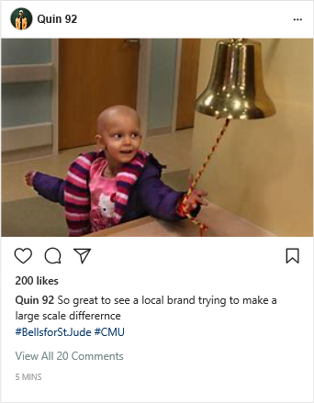

- Desiree Linden Post
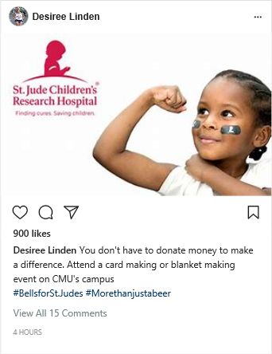
- Rich Eisen Post
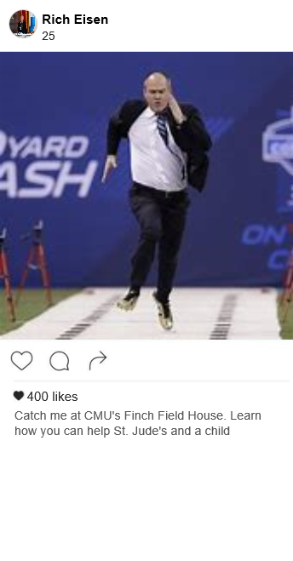

Press Release

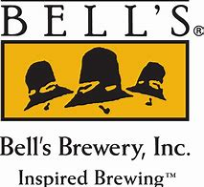

Media Contact
James McLellan, President of Communications
Email: Mclel1jp@cmich.edu
Bells for St. Jude’s

MOUNT PLEASANT, Mich. – Bells Brewery is excited to announce a partnership with St. Jude Children’s Research Hospital.

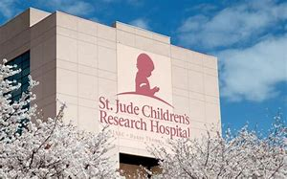
The partnership began in February of 2019 and the two organizations are going to come together next fall to raise money for research specifically devoted to childhood cancer. The campaign will consist of a week long event on Central Michigan University’s campus, giving students the opportunity to have fun, learn, and give back.
“The partnership is one of a kind.” Said James McLellan, President of Communications at Bells Brewery. “Really, the partnership has a symbolic meaning behind the whole campaign. Traditionally after a patient has completed all of their necessary treatment with chemotherapy and radiation, the treatment facility has a ceremony for that patient celebrating how far they’ve come and what they had to go through. In that ceremony the patient rings a bell and reads a poem besides it.”
Recognizing this, Bells Brewery will be hosting a week long campaign where students can make blankets, write cards, or just give their support to kids currently in St. Jude’s for treatment of cancer and other related illnesses. At the end of the week there will be a event hosted at Finch Field house with visits from Rich Eisen and Desiree Linden for students to attend.
This week long campaign will run from October 6, 2019 to October 11, 2019.
About Bells Brewery
Bell's Brewery, Inc. began in 1985 with a quest for better beer and a 15 gallon soup kettle. Since then, we've grown into a regional craft brewery that employs more than 550 people over a 39 state area, in addition to Puerto Rico and Washington DC. The dedication to brewing flavorful, unfiltered, quality craft beers that started in 1985 is still with us today. We currently brew over 20 beers for distribution as well as many other small batch beers that are served at our pub in Kalamazoo, the Eccentric Cafe. Our ongoing goal is to brew thoughtfully, creatively and artistically. 100% family-owned and independent, we strive to bring an authentic and pleasant experience to all of our customers through our unique ales and lagers. For more information, please visit bellsbeer.com.

Flyer

